2026 Kentucky Envirothon
Current Issue – Nonpoint Source Pollution
- Define nonpoint source pollution (NPS) and distinguish it from point source pollution.
  - https://www.epa.gov/nps/basic-information-about-nonpoint-source-nps-pollution
  - https://eec.ky.gov/Environmental-Protection/Water/Protection/Pages/Nonpoint-Source-Pollution.aspx
  - Describe challenges in monitoring, quantifying, and managing NPS pollution compared to point source pollution
- Describe Section 319 of the Clean Water Act (CWA)
- Identify local and global sources of nonpoint source pollution.
- List major pollutants associated with NPS pollution.
- Identify NPS pollutants in urban and agricultural environments.
- Explain how precipitation and water runoff transport pollutants into surface water and groundwater.
- Evaluate how land use (agriculture, development, forest etc.) and physical features (slope, impervious cover, vegetative buffer) influence runoff and pollutant transport.
- Analyze the environmental, economic and human health impacts of nonpoint source pollution on watersheds and aquatic ecosystems.
- Describe the impacts of NPS pollution on water quality and designated water uses (e.g. recreation, fisheries, drinking water)
- Explain the role of watersheds in the movement of NPS pollution.
- Delineate a watershed on a topographic map and indicate where water flows and into what body of water.
  - https://modelmywatershed.org/
- Interpret basic maps, aerial imagery, or field data to locate potential sources of NPS pollution in a given watershed
- Describe eutrophication and its connection to excess nutrients (nitrogen and phosphorus).
- Know what hypoxia means, the causes of hypoxia, and how it is currently affecting the Gulf of Mexico (see https://www.epa.gov/ms-htf).
- Describe soil erosion and sediment transport as major contributors to NPS pollution.
- Identify and explain best management practices (BMPs) use to reduce NPS pollution (riparian buffers, cover crops, rain gardens, no-till, detention basins).
- List structural and non-structural BMPs (rain gardens vs water use conservation).
- Describe other co-benefits of implementing BMPs (alternative waterers=healthier livestock).
- Define Low Impact Development and explain how green infrastructure helps reduce runoff and pollutant loads.
- Evaluate the effectiveness of BMPs in different land-use settings.
- Calculate pollutant loads
  - Actual Concentration x Discharge (cfs) x Conversion Factor = Actual Load
Conversion Factors
Parameter Unit | Daily Load | Monthly Load | Annual Load
CFU/ 100 mL | 24405408 | 742331160 | 8907973920
mg/L | 5.39 | 164.07 | 1968.80

Video Resources
- Source water, NPS, and BMPs (https://www.youtube.com/watch?v=-bvZCdMecEo)
- Stormwater runoff and pollutants entering into body of water (https://www.youtube.com/watch?v=QUUwzLrBZ5M)
- Protecting our watersheds (https://thinktv.pbslearningmedia.org/resource/protecting-our-watersheds-untamed-video/untamed-the-wildlife-center-of-virginia/)

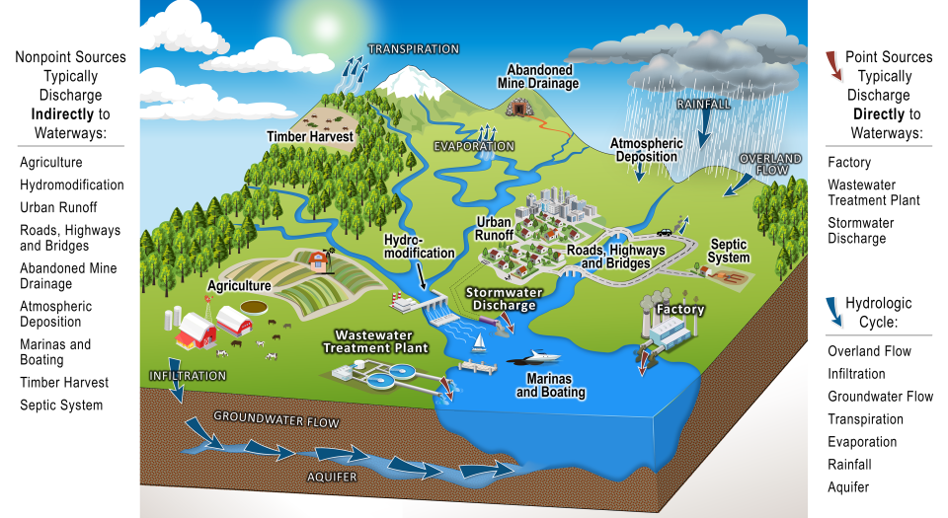
https://www.epa.gov/system/files/documents/2024-11/508_final-nps-diagram_11-18-24.pdf

